From Shehryar(bsf2000745)

Umar draz( bsf2000921)

Physiological Consideration

**Test Administration should avoid inducing and should work in test anxiety**

Health care education is an important issue in the development of student’s academic achievement plays an important role in this respect. Test anxiety can affect the academic performance of students.

**Some Anxiety Reason:**

Poor study habits, poor past test performance, and an underlying anxiety problem can all contribute to test anxiety. A few potential causes of test anxiety include:

**Fear of failure:**

If you connect your sense of self-worth to your test scores, the pressure you put on yourself can cause severe test anxiety.

**Poor testing history:**

Either if you have done poorly on tests before, because you did not study well enough or because you were so anxious, you could not remember the answers, this can cause even more anxiety and a negative attitude every time you have to take another test.

**Unpreparedness:**

If you did not study or did not study well enough, this can add to your feeling of anxiety.

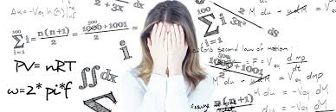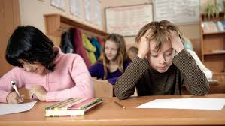

**During examination hall how Examiner reduce anxiety of students**:

Teaching students specific examination and revision techniques to increase their sense of agency and competence

**Neat, Clean lightning and Airy Classroom:**

If Class clean neat. Student fell comfortable and easy. If sitting arrangement are good and room well airy. Student feel mentally relax. Sometime in rainy days and thunderstorm days room under darkness. Some students have eyesight issue. If room is well lightening, Student feel well and relax. These things reduce the anxiety.

**How to start paper:**

At beginning, if examiner pass through all instruction how to start paper clearly. How to fill the objective type paper. How to fill computerized. How to start subject type paper. Where you written your name, Roll No and other important thing. No ink remover use, No extra paper is available. All paper fit on your given paper sheet. This thing is also reduce anxiety.

**Read carefully:**

If examiner read the paper carefully in overall class. If there is any mistake Students feel in paper than arise question and clear his confusion And Examiner contact with Control Board. If there is change in paper then change. This thing reduce the anxiety.

**Hang Clock in front on the wall:**

Time is most an aspect in exam. If there is, clock in class then its help all students. Clock always hand in front of the room wall that help the student to see the clock easily. This thing reduce the anxiety.

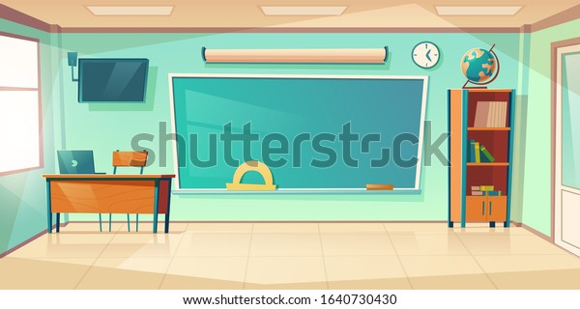

**Stop Communication:**

If there is noise in class, if student whisper with one another. Other student feel uncomfortable. In addition, Sometime its effect on its mind. Sometime student forget his paper. It has put bad impact on paper. At this situation, Examiner control the class. This thing reduce the anxiety.

**Language difference:**

Sometime language create confusion between different students. This problem is mostly created from Urdu medium students. If teacher exact clear the point of student. Then student feel easy. This thing reduce anxiety.

**Test time planned:**

Test time must be planned and communicate to the student. If examiner inform frequently then student manage his paper according to the time. This help the student.

**Examiner Behavior during examination:**

**Not favoritism:**

Examiner behavior should be good during conducting exam. In Examination Hall, examiner behavior should be professionally not social behavior. If examiner behavior is social, then students may be use misbehave language. If examiner has social behavior and help the student in solving the paper. Sometime during exam favoritism, include.

Other student think which type of the examiner in this room. That why Examiner behavior should be professional and create Equality in all student and not discourage other student

How effort in overall year.

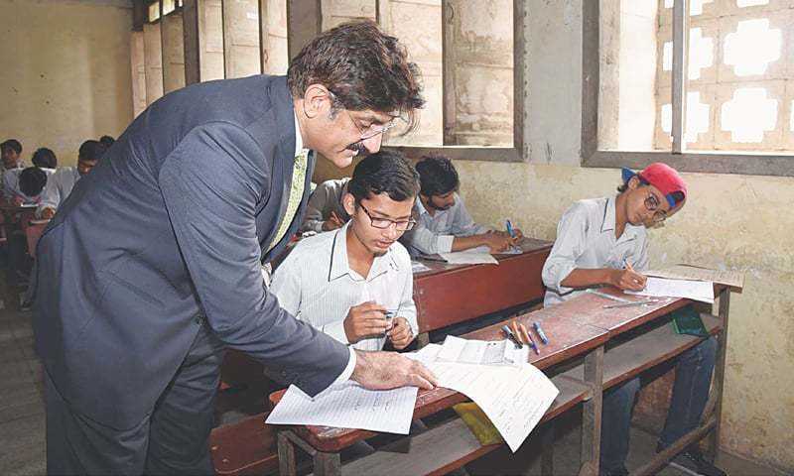

**Not speak loudly:**

Examiner speak not loud during examination like calling phone. This habit disturb the student mentally. From this, habit some student forger his paper. That why examiner speak slowly.

**Avoid food and smoking:**

During Examination hall, Examiner not use food (like samosa, tea). This habit disturb the student. Food smell change the student mind. Examiner avoid from smoking. Some student irritate from smoke smell. All thing create bad impact on students and its paper.

**How examiner observe the student examination:**

Examiner should be actively mind. Examiner should observe the class repeatedly from avoid cheating. Most of the cases those students how involve in cheating his facial expression mostly change. Examiner should examine the student different point of view. Examiner see the student cloth, Calculator cover, his socks, and his geometry box. Examiner round the class frequently from interfacing sheet with one another.

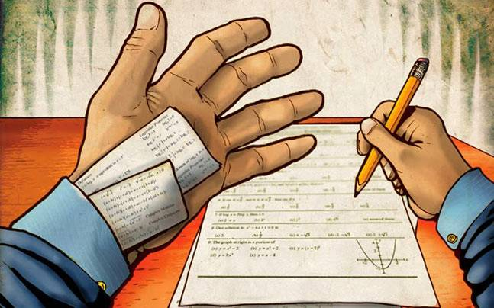

1. <https://www.sagepub.com/sites/default/files/upm-binaries/36361_Chapter1.pdf>
2. <https://www.caluniv.ac.in/academic/Education/Study/MA-S-IV-Guidence.pdf>
3. <https://www.educause.edu/research-and-publications/books/learning-spaces/chapter-6-psychology-learning-environments>
4. <https://scholarworks.lib.csusb.edu/cgi/viewcontent.cgi?article=3614&context=etd-project>
5. <https://www.topuniversities.com/blog/types-students-behavior-during-exam-season>
6. <https://ntu.edu.pk/qec/duties-and-responsibilities-of-a-teacher/>
7. <https://edusanjal.com/blog/types-students-during-exam/>
8. <https://citl.illinois.edu/citl-101/teaching-learning/resources/classroom-environment/dealing-with-cheating>